**THE FOLDING EDGE**

**Overview**

The Folding Edge website is designed to provide users with an interactive and informative platform to explore the art of origami. The website consists of five main pages:

* **Home**
* **About Us**
* **Contact Us**
* **Feedback Form**
* **Gallery**

Each page serves a specific purpose to enhance user experience and engagement.

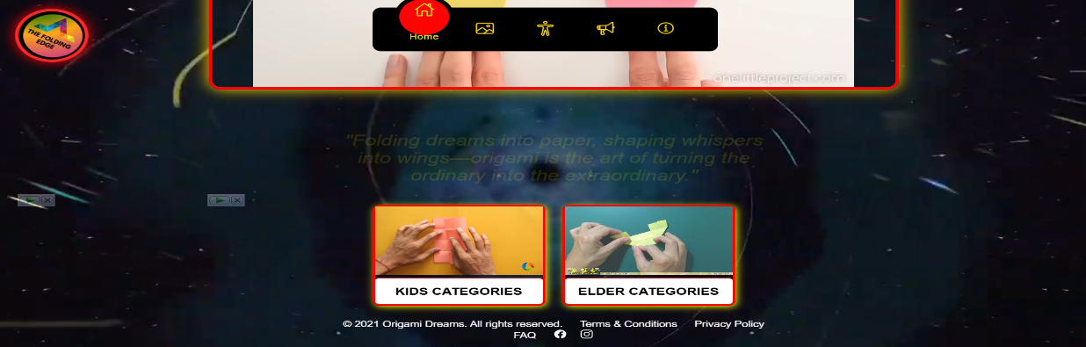

**1. Home Page**

Description

This HTML file creates a visually appealing origami-themed website with a fixed navigation bar, a logo, a video carousel, animated quotes, and category cards for kids and elders. It includes interactive JavaScript for navigation, a slideshow, and dynamic quotes. The design features a dark theme with glowing accents, making it engaging for users.

Features

• **Navigation Bar** – A stylish, animated navbar with active state indicators.

• **Video Carousel** – A sliding carousel that auto-plays origami tutorial videos.

• **Dynamic Quote Generator** – Displays rotating inspirational origami quotes.

• **Category Cards** – Two sections for kids and elders, each with interactive videos.

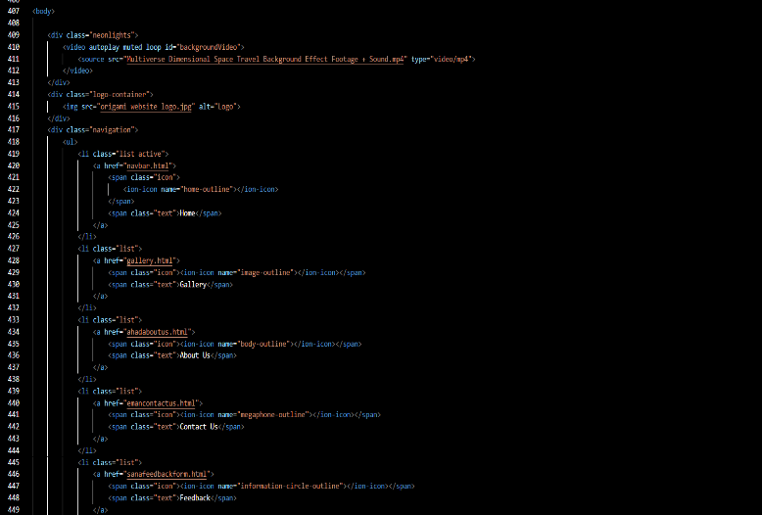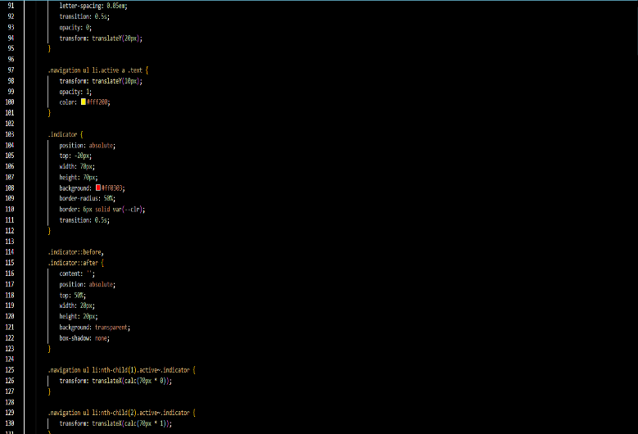

## 2. About Us Page

Description

This is the **"About Us"** page of the **Origami Website** called **Folding Edge**. It provides an overview of the website's purpose, mission, and community while featuring a stylish navigation bar, a background video, and animated content for an engaging user experience.

Features

• **Animated Navigation Bar** – Highlights the active page with smooth transitions.

• **AutoPay Background Video** – Enhances visual appeal and engagement.

• **Sliding Info Cards** – Sections appear with smooth animations for a dynamic user experience.

• **Interactive Footer** – Includes important links and social media icons.

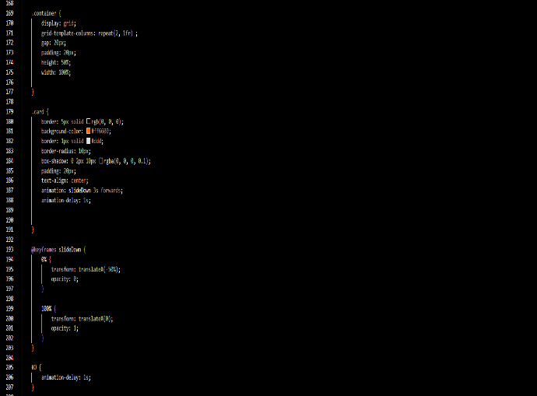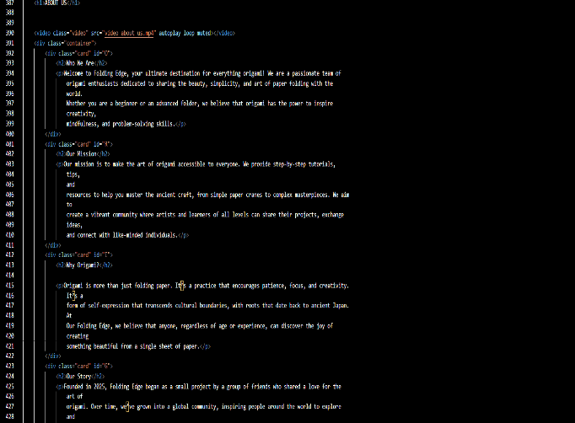

**3. Contact Us Page**

Description

This is a responsive **Contact Us** page for the Origami website. It includes a **navigation bar, a contact form, and a footer** with social media links. Users can submit queries, attach files, and get in touch with the website team.

Features

• **Interactive Navbar** – Highlights active page with smooth transitions.

• **Contact Form** – Supports text input, dropdowns, and file uploads.

• **Responsive Design** – Adapts to all screen sizes.

• **Animated Logo & Footer** – Rotating logo and social media links.

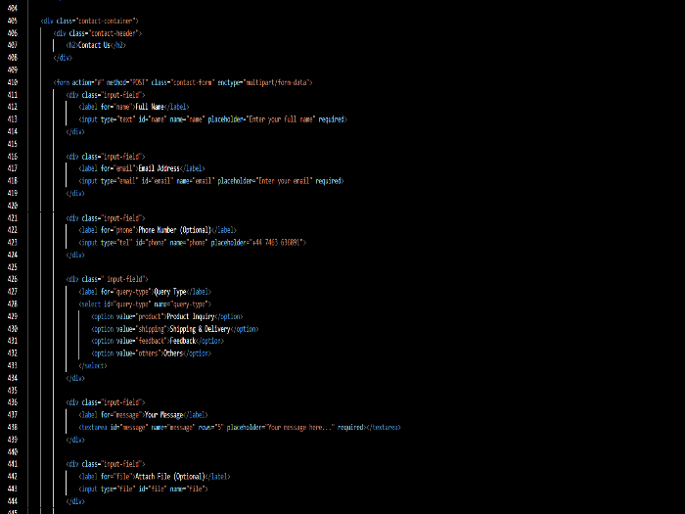

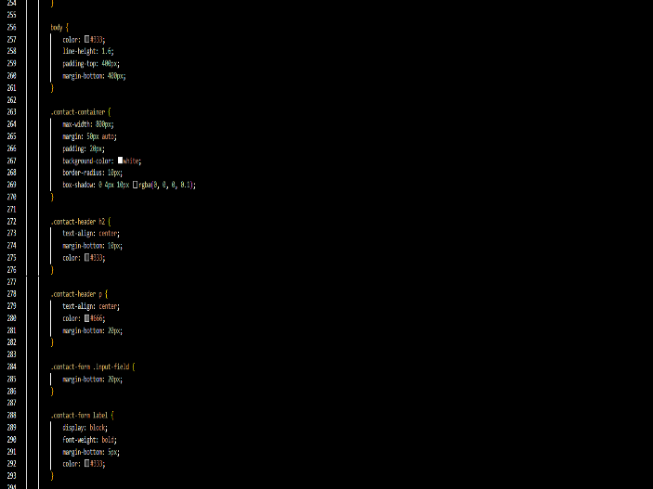

**4. Feedback Form Page**

Description

This **Feedback Form Page** allows users to share their experience and suggestions for the **Origami Dreams** website. It features a clean and responsive design, ensuring smooth navigation and interaction.

Features

• **Interactive Navbar** – Highlights the active section for easy navigation.

• **Animated Logo** – Rotates with effects, enhancing visual appeal.

• **User-Friendly Feedback Form** – Supports text input, dropdowns, and file uploads.

• **Responsive Design** – Works seamlessly across all screen sizes.

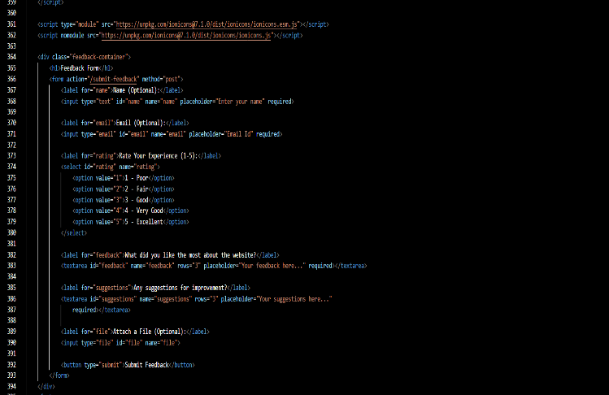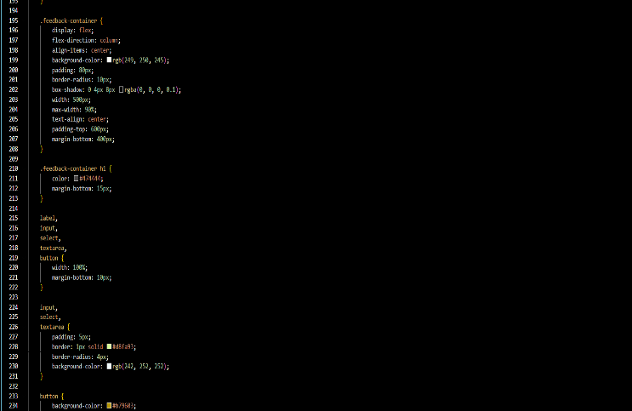

**5. Gallery Page**

Description

The **Gallery Page** displays a collection of images in a grid layout. It includes features like image previews, categorization, and responsiveness for different screen sizes. Users can click on images to view them in a larger size. The page is optimized for fast loading and a smooth user experience.

Features

• **Responsive Design** – Adjusts layout for all screen sizes.

• **Image Preview** – Click to view images in a larger size.

• **Categorization** – Sort images into different categories.

• **Fast Loading** – Optimized for quick image rendering.

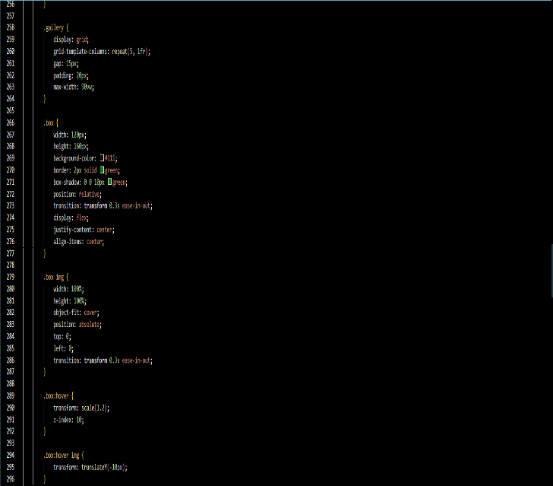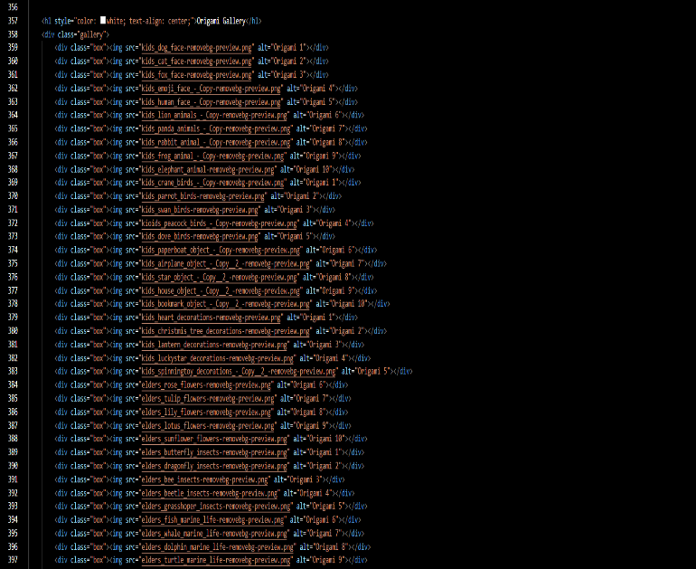

Technologies Used

* HTML, CSS, JavaScript
* Bootstrap/Tailwind for styling (optional)
* JavaScript/jQuery for lightbox effect (if applicable)

Customization

* Modify CSS for different layouts (grid, masonry, carousel).
* Implement additional interactivity using JavaScript.
* Optimize images for faster loading. Features like filtering or search can be integrated.

**Page Structure**

* Header: Navigation bar for easy access to other sections.
* Gallery Section: Grid or masonry layout displaying images.
* Lightbox (Optional): Enlarged view of selected images.
* Footer: Additional links and copyright information.

**6.Conclusion**

The code implements a **Gallery Page** with a **responsive design**, allowing users to **view, categorize, and preview images** efficiently. It ensures **fast loading** and an **interactive UI**, making it user-friendly for all devices. The page is optimized for **performance and smooth user experience**.